Task Number: Task 1
Project: Iris Classification
Name: Gopala Vishalini
Internship: Alfido Tech

GitHub:
https://github.com/VishaliniGopala/Iris-Classification

Model File:
https://drive.google.com/file/d/1oB6DnkMtn8jNOW31GkX22npdh8uQlhjm/view

Screenshots:
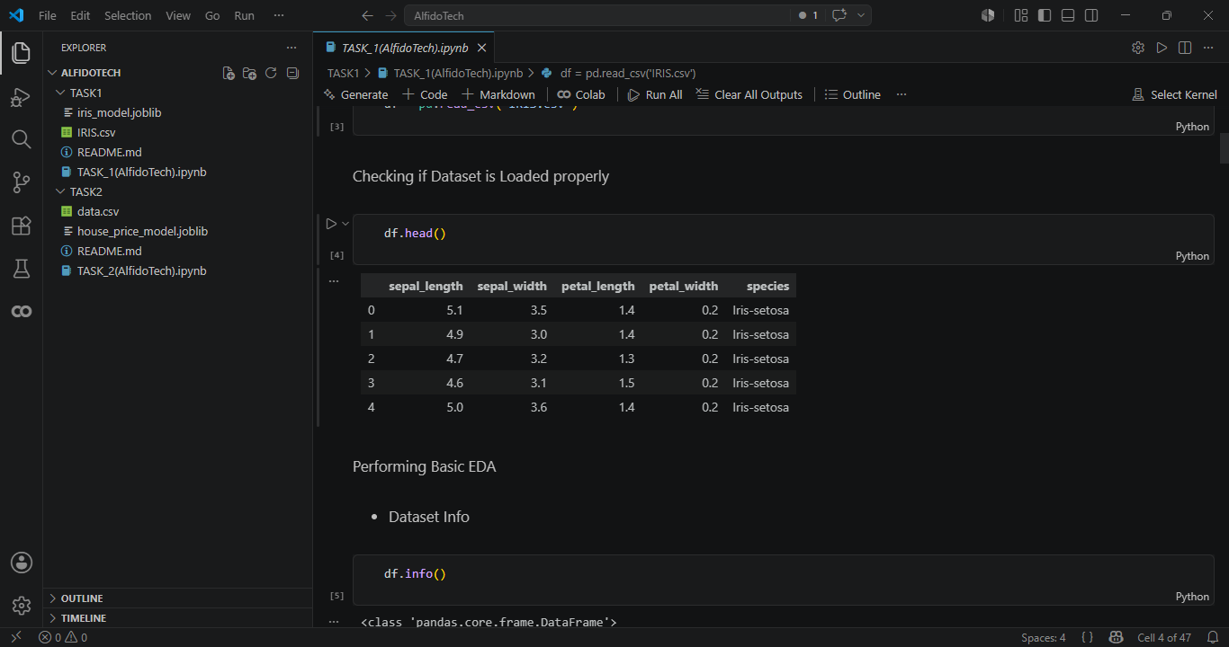

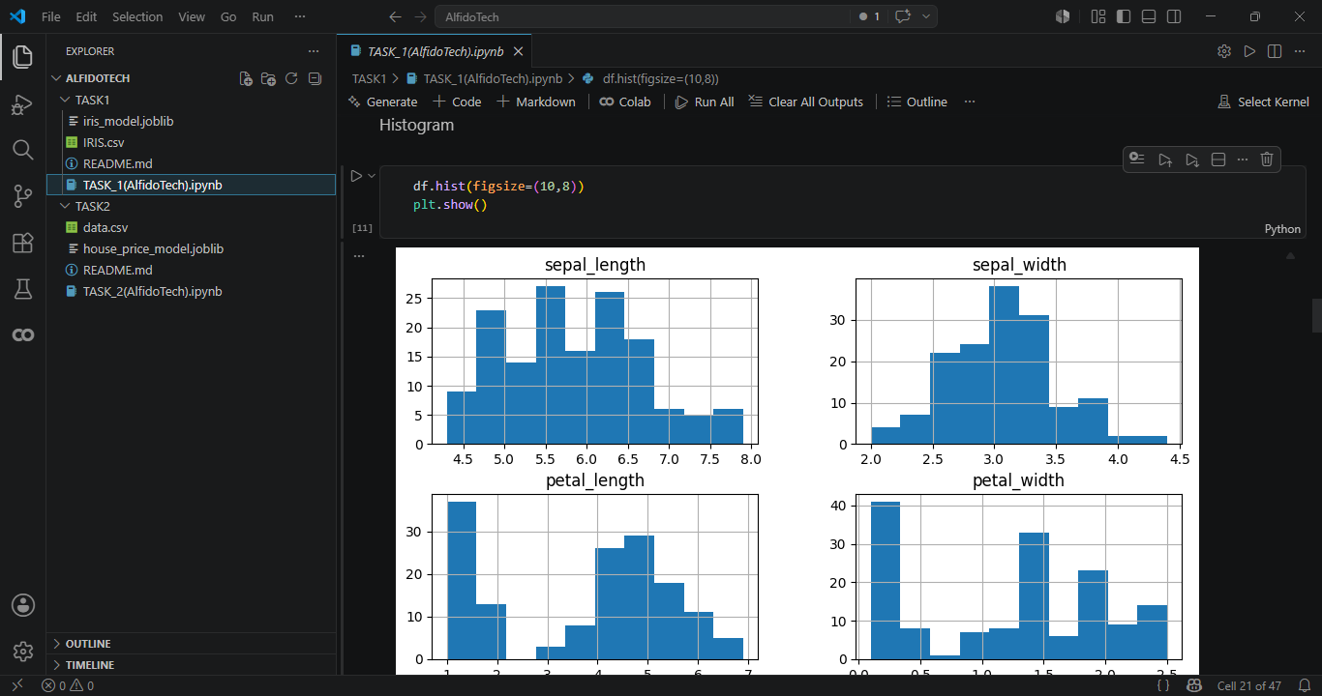
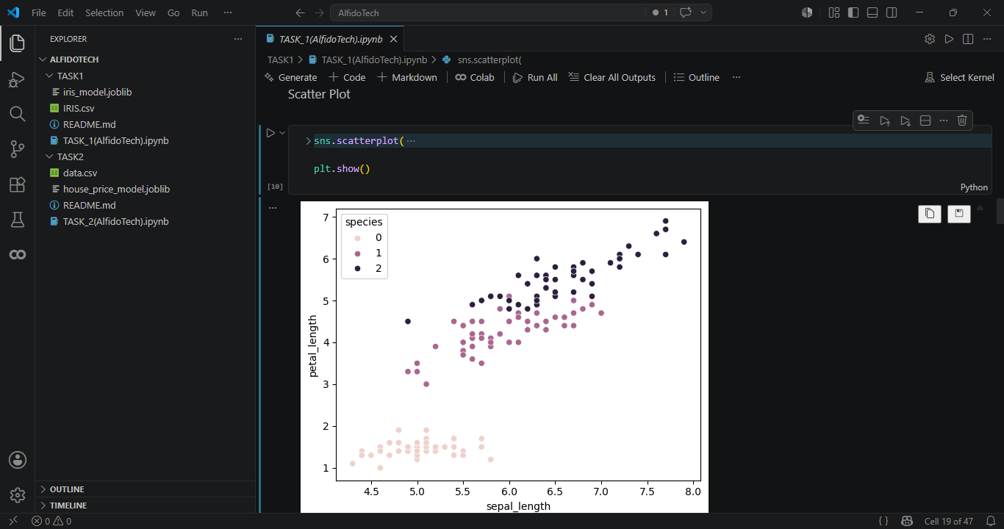
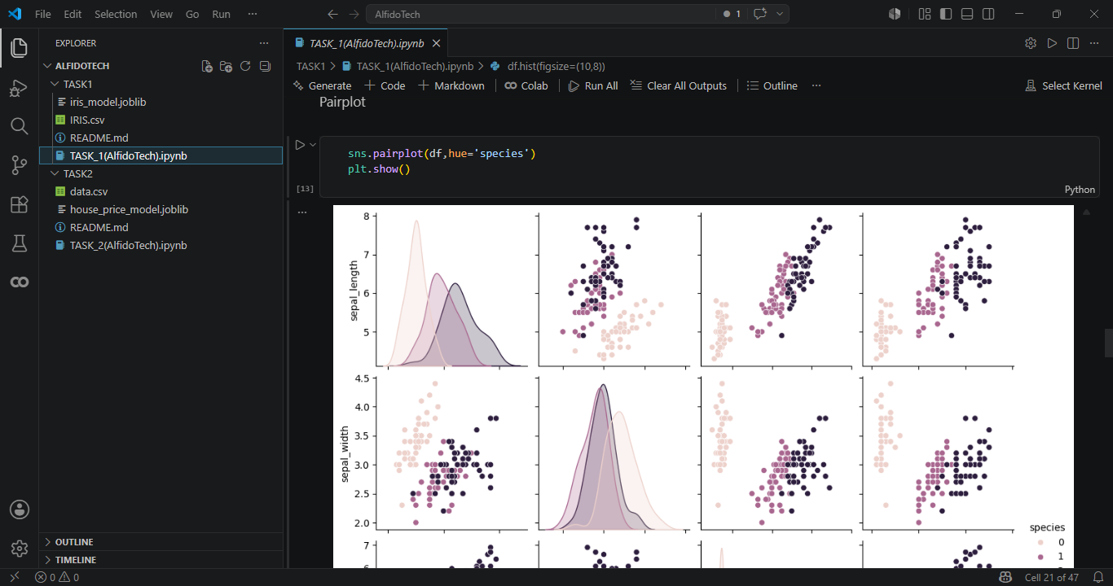
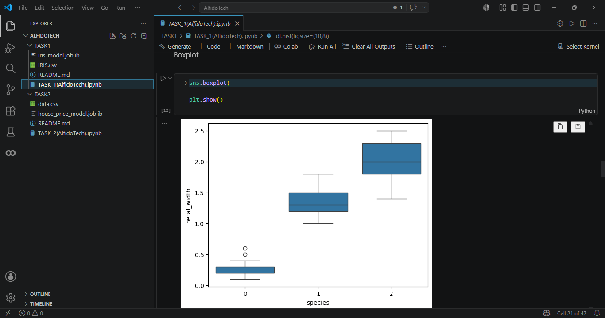
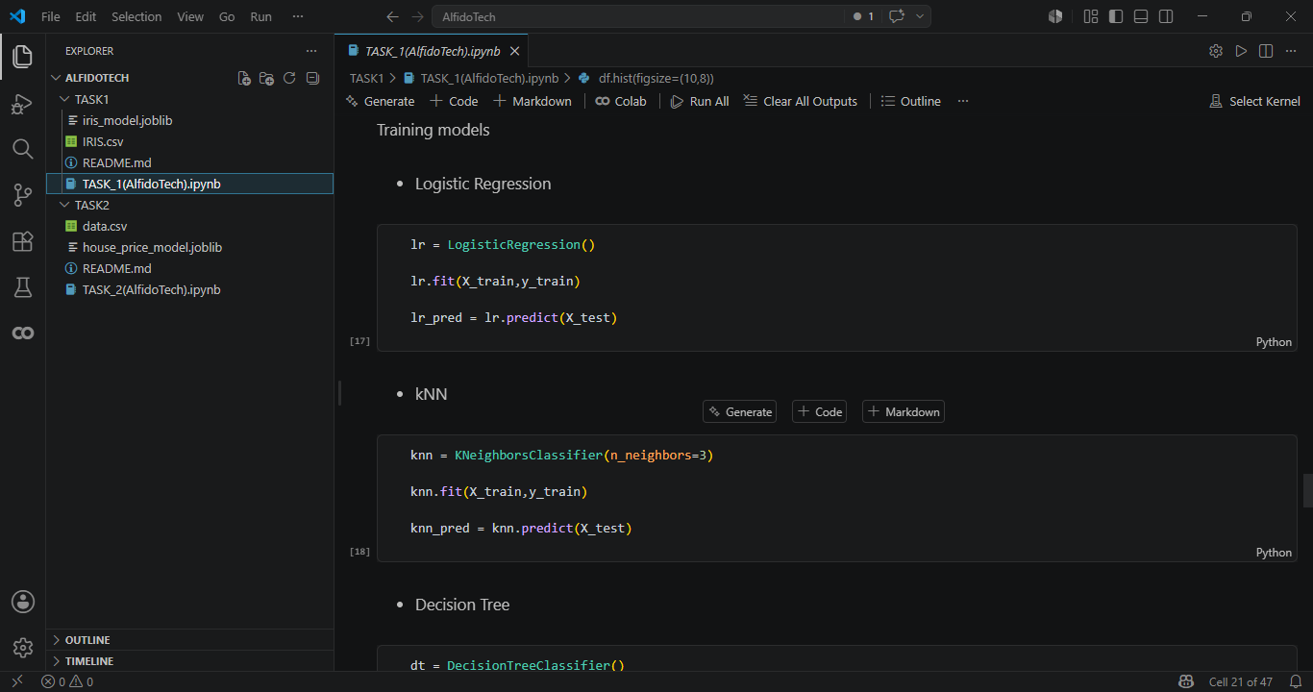
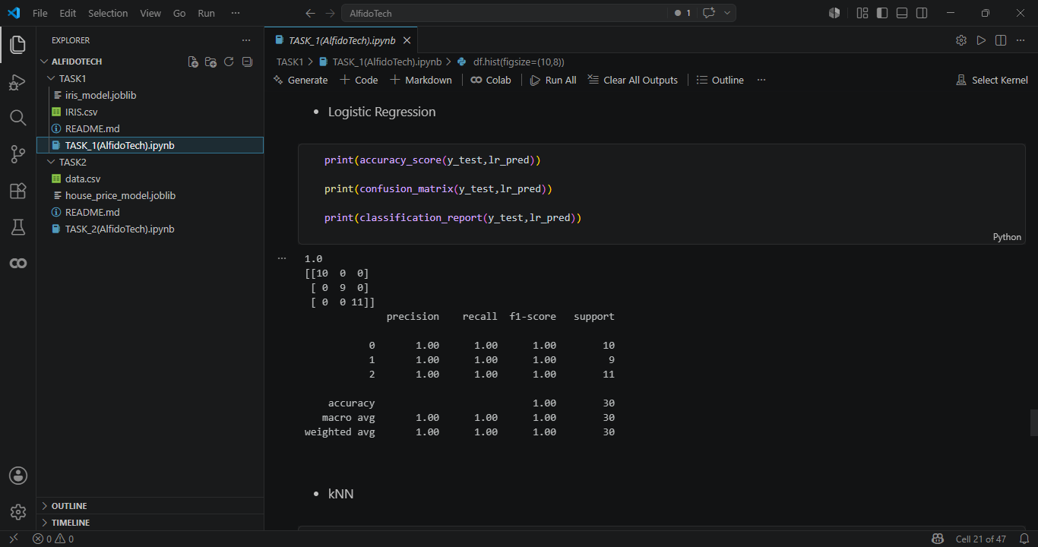
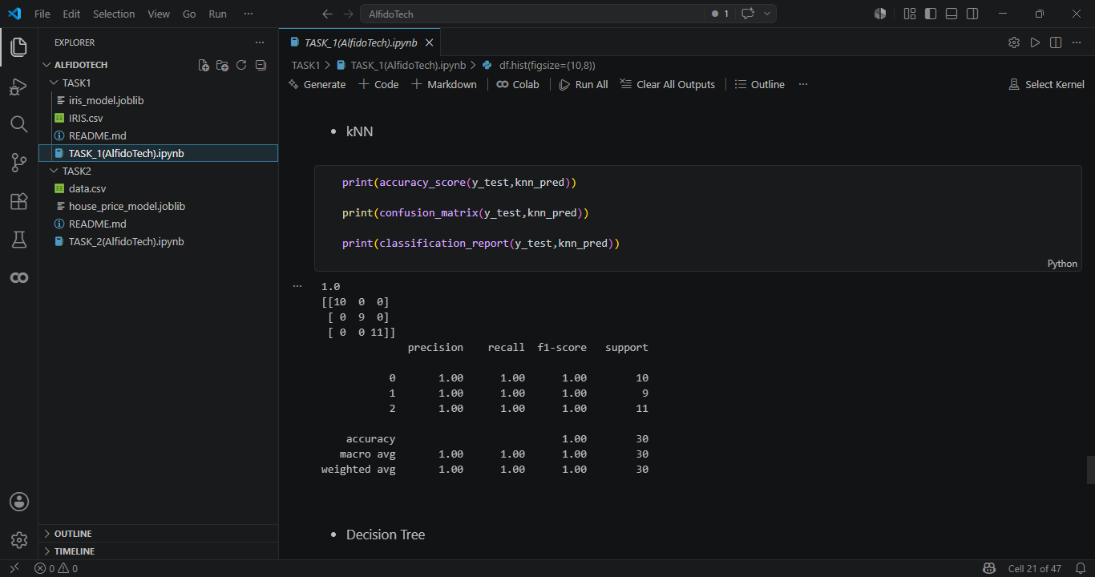
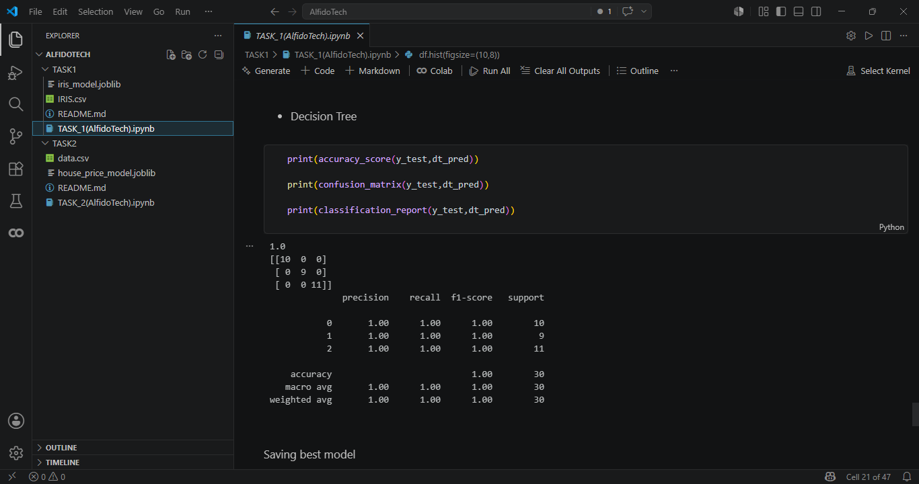
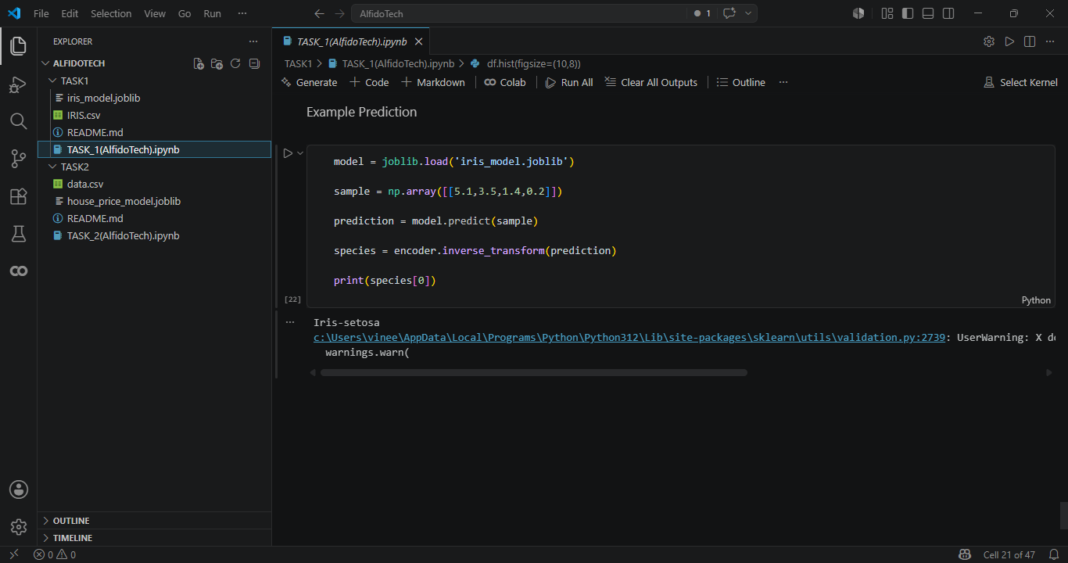

Summary — Task 1: Iris Classification
Objective
The objective of this project was to build a machine learning classification model capable of predicting Iris flower species using classic flower measurements. The dataset contains four numerical features: Sepal Length, Sepal Width, Petal Length, and Petal Width. The target variable is the flower species.
Methodology
The project began with Exploratory Data Analysis (EDA) to understand the structure and characteristics of the dataset. Initial analysis included dataset inspection using head(), info(), describe(), and missing value analysis.
Several visualizations were created to analyze class separability and feature relationships, including:
- Scatter Plot
- Histogram
- Boxplot
- Pairplot
The categorical target variable (Species) was converted into numerical form using label encoding. The dataset was then divided into training and testing sets using an 80-20 split.
Models Implemented
Three machine learning algorithms were trained and compared:
- Logistic Regression
- k-Nearest Neighbors (k-NN)
- Decision Tree Classifier
These models were selected to compare different classification approaches and determine the most effective algorithm for the Iris dataset.
Evaluation Metrics
Model performance was evaluated using standard classification metrics:
- Accuracy
- Confusion Matrix
- Precision
- Recall
The comparison of results enabled selection of the best-performing model based on predictive accuracy and classification performance.
Results and Outcome
The trained models demonstrated strong performance in classifying Iris flower species. Visual analysis showed clear separability among classes, contributing to high classification accuracy. The best model was saved using Joblib/Pickle for future reuse and deployment.
An inference example was also implemented to demonstrate how new flower measurements can be supplied to the saved model for prediction.
Technologies Used
The project was implemented using:
- Python
- Pandas
- NumPy
- Matplotlib
- Seaborn
- Scikit-Learn
- Joblib / Pickle
Conclusion
This project successfully developed a machine learning classification system for predicting Iris species using flower measurements. The implementation demonstrates the complete machine learning workflow, including preprocessing, visualization, model training, evaluation, and deployment-ready model saving.

